**Physics IA Proposal**

**Topic:**

**General:**

The experiment that I am trying to recreate is an experiment that demonstrates the relationship between the speed vs the wavelength of the water wave on the surface of the water. My experiment will be doing so by creating different waves in a container, and then using a digital camera to film the entire process. The video will then be analyzed with technology to calculate the speed of the wave and wavelength using techniques such as counting frames and measuring with ratio and tirg.

**Topic related to:**

Wave - The experiment is exploring how the wavelength of water will effect the speed of the wave

Conservation of energy - equation will be using principles of conservation of energy to find the relationship between the depth of water and the frequency

**Goal:**

**Aim:**

The aim of my research is to find the relationship between the depth of water, and the frequency of the water’s surface wave, and how the frequency of the wave will change according to the change in the depth of the water

**Hypothesis:**

If the depth of the water is decreased, then the frequency of the surface water wave will increase,

**Variables:**

**Independent Variables:** depth of water

**Dependent Variable:** frequency of wave

**Possible extraneous variables:**

Temperature of water, gravity, amount of energy that the wave carries, water surface tension, wind, air pressure

**Control for extraneous variable**

Temperature of water will be room temperature, wind will be reduced minimizing movement and closing the windows. All extraneous variables will be controlled (more detail in fallowing chart)

**Measuring the Variables**

|  |  |  |
| --- | --- | --- |
| Variable | Method to measure | Method to control |
| Depth of water | Ruler | Add certain amount of water to container until reach height expected (measured with ruler) |
| Temperature of water | Thermometer | Keep water in a stable room temperature and avoid strong radiation to maintain same temperature |
| Slope of table | Electronic level | Put level on table, and add paper under to balance according to level. |
| Amplitude of wave | Computer calculation with camera picture | Wave will be produced with a cylinder, which will have a maximum and minimum height which it will reach and then start to move the opposite direction. |
| Type of wave | Camera picture & graph overlay | Slope will be pushed into the water using a cylinder, thus fallowing a circular motion height. Theoretically, that should produce a sine wave when speed of cylinder is constant. |
|  |  |  |

**Design:**

**Design:**

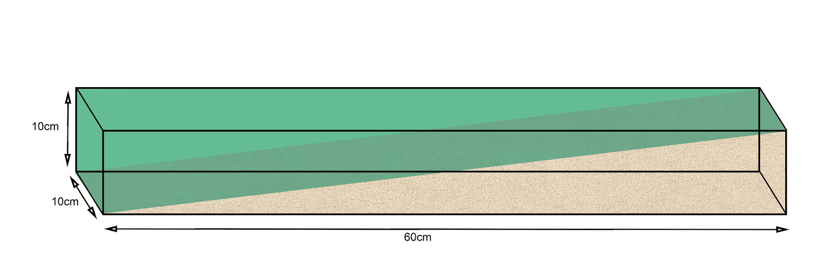

**Description:** The tank will be made out of acrylic sheets with thickness of 0.08 inch, suck together with silicone sealing. The water will not be filled up to complete full, and the sand will be leveling up in a way such as stairs  so it will be easier to get measurements. Wave will be produced on the left side with equal wavelengths, and there will be a camera on top and on the side of the container observing it.

**Material:**

* Acrylic container (10*10*60 in cm)
* Water 3L
* Sand 3L
* Acrylic board (10*3 in cm)
* Tripod * 2
* Camera * 2

**Relationship:**

Through research, though the formula is very complex, the expected relationship between the depth of the wave and the frequency will be inversely exponential. Since the depth would be more than ½ wavelength in my experiment.

**Equation:**

$$c_{p}=\sqrt{\frac{gλ\tanh\left(\frac{2πd}{λ}\right)}{2π}}$$

$c_{p}$ = velocity of wave ($ms^{-1}$)

g = gravity ($m^{2}s^{-1}$)

h = height ($m$)

$λ$ = wave length ($m$)

d = depth ($m$)

When

$$d>\frac{λ}{2}$$

$\tanh\left(\frac{2πd}{λ}\right)=1-0.001$

Therefore

$tanh⁡(\frac{2πd}{λ})≈1$

then the formula becomes

$$c_{p}≈\sqrt{\frac{gλ}{2π}}$$

which can be rearranged to

$${c_{p}}^{2}=\frac{gλ}{2π}$$

Since gravity and $π$ are constants, there fire, v and $λ$ will have a quadratic relationship

Since $d>\frac{λ}{2}$ for the approximation to be true

And $d=10cm$

Therefore, equation will work for any $λ$ if and only if $λ<20cm$

**Safety:**

This experiment should be 100% safe because it does not use any dangerous chemical nor use any sharp tools that may potentially hurt me. The only danger of this experiment is that I may break a camera if I drop it.